Zoom Landing

**Topic:** *When Tech Helps—and When It Hurts—the Human-Animal Connection*

### **🐾 Veterinary Technology & Innovation Panel**

### ***When Tech Helps — and When It Hurts — the Human-Animal Connection***

📅 **Date:** Wednesday, October 22, 2025  
 🕗 **Time:** 8:00 PM – 9:00 PM EST  
 💻 **Platform:** Live Zoom Event  
 🎙 **Format:** Panel Discussion + Interactive Q&A

#### **About the Event**

Technology has transformed veterinary medicine — from telemedicine and remote monitoring to AI diagnostics and automated client communications. But while innovation brings new possibilities, it also raises a vital question:

#### **What You’ll Learn:**

🐾 The benefits of telemedicine and remote monitoring  
 🐾 The risks of over-reliance on automation in client interactions  
 🐾 How to balance efficiency with a personal touch  
 🐾 Training staff to use tech tools while keeping empathy at the forefront  
 🐾 How technology can improve compliance and patient follow-up

#### **Why Attend?**

✅ Gain practical insights from veterinary professionals who successfully integrate technology with compassionate care  
 ✅ Learn strategies to strengthen client relationships in a digital world  
 ✅ Participate in a live Q&A and share your experiences

🩺 **Join us for an evening of innovation, empathy, and inspiration — and discover how technology can elevate care without replacing the heart of the profession.**

👉 **Reserve your spot today!**

Rhonda Bell

* Full Name - [**Rhonda Bell**](https://www.linkedin.com/in/rhondabellcvpm/overlay/about-this-profile/)
* Contact Number - 858-220-5000
* Current Position and Organization - Certified Veterinary Practice Manager | Digital Marketing Strategist | Speaker | Career & Leadership Coach
* Email Address -rhonda@dogdaysconsulting.com
* Short Bio (3-4 sentences) -

Rhonda Bell, CVPM, PCM-Digital, CDMP, is a seasoned veterinary practice management expert and the founder of Dog Days Consulting. With over 20 years of experience in veterinary leadership and digital strategy, she empowers practices to build meaningful client relationships while navigating the demands of modern technology. Rhonda’s work highlights the importance of balancing efficiency with authentic connection, cautioning against the risks of over-relying on technology in client relationship building. Her coaching and speaking engagements help veterinary teams integrate digital tools thoughtfully, without sacrificing the human element that drives trust and compliance.

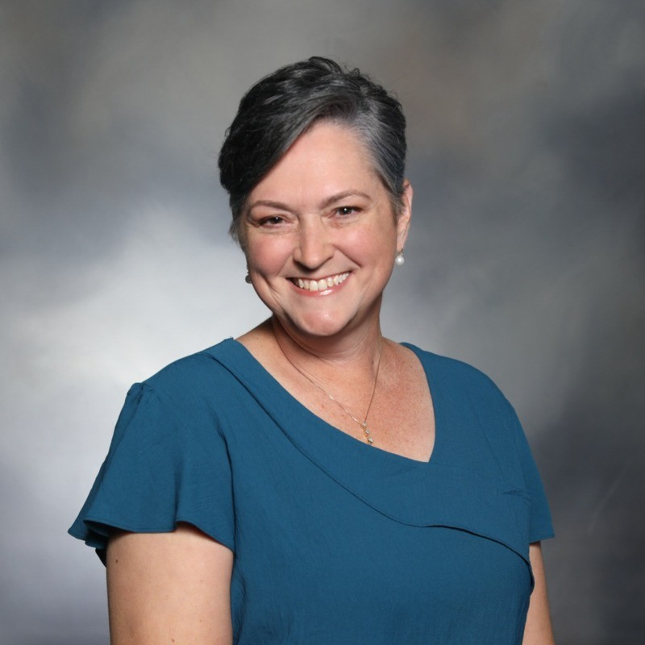

Amanda Landis-Hanna

* Full Name - [**Amanda Landis-Hanna**](https://www.linkedin.com/in/amanda-landis-hanna/)(Co-host-VBI)
* Contact Number - 858-361-3324
* Current Position and Organization - Cofounder | Chief Veterinary Officer | Veterinary Innovator
* Email Address - amanda.landishanna@yahoo.com
* Short Bio (3-4 sentences) -

Veterinary thought leader with expertise in technology, innovation, veterinary and consumer engagement, and project management. Special focus on nonprofit management, relationship development, research, veterinary education models, advocacy, and accessible veterinary care. Skilled public speaker, strategist and mentor with experience in hands-on practice, social media and content production.

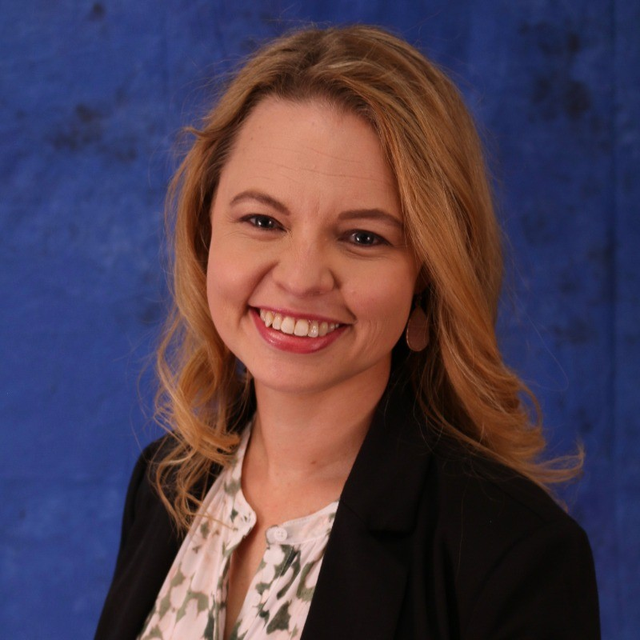

Tab 3